
Stewart Audio 5/30/23 Webinar Script
PowerCore™ DPA-220 Series Intro v2.0

Zoom Webinar URL: https://us02web.zoom.us/j/86022741023
SA Marketing Center (Internal): https://pmopanda.com/project-center/stewart-audio-project-center/
SA Sales Center (External): https://stewartaudio.com/stewart-audio-manufacturer-reps-sales/
Password: SA2023AMPCON
Presenters: Stephen, Brian, Cody, and Doug

🔴 Turn on Recording – Doug
Note: Doug will be driving slides.

Stephen - Workshop Introduction



- Hello Everyone!
- I’m Stephen Thomas, Director of Sales at Stewart Audio and SP Controls.
- I’d like to welcome you to our PowerCore™ DPA-220 Amplifiers Series webinar.
- We have a very exciting and informative session planned for you today.
- In the next hour we’ll tell you about the capabilities of our new PowerCore amplifiers as well as a new sales portal we’ve built with all kinds assets and tools to help you position and sell our products more effectively.
- I’d also like to mention that we’ll be recording this webinar for those of you who would like to share today’s presentation with colleagues.

Stephen - Today’s Presenters

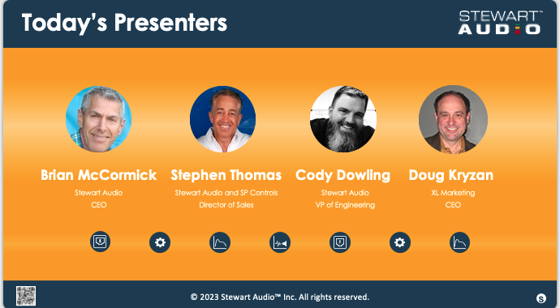
- The folks who will be presenting today are:

Brian McCormick
Stewart Audio - CEO
Stephen Thomas
Stewart Audio and SP Controls – Director of Sales
Cody Dowling
Stewart Audio - VP of Engineering
Doug Kryzan
XL Marketing - CEO

Stephen - Agenda

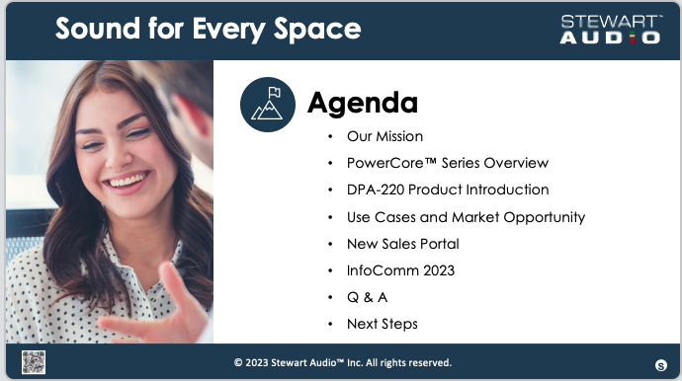

- The topics we’ll be covering in our webinar today are:

  - Our Mission
  - PowerCore™ Series Overview
  - DPA-220 Product Introduction
  - Use Cases and Market Opportunity
  - New Sales Portal
  - InfoComm 2023
  - Q & A
  - Next Steps

- And with that I’d like to turn it over to Brian who will share a few words about our goals and strategy for 2023.

Brian - Mission

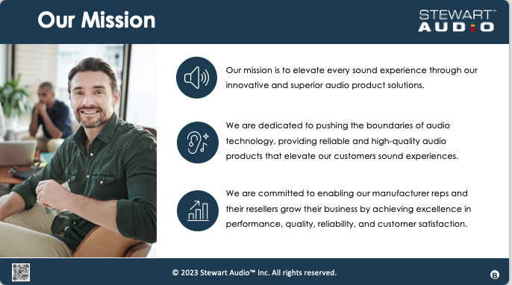

Segue to Cody who will present the following 4 slides.

Cody – PowerCore™ Overview, DPA-220, DPA-220+ and Product Comparison

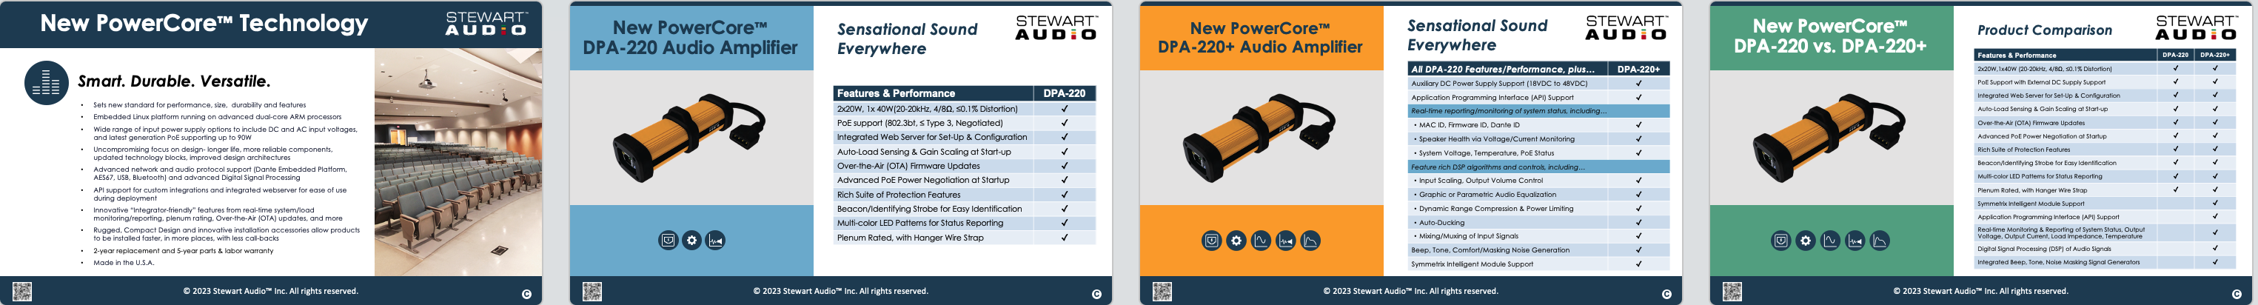

Segue to Stephen

Stephen – Applications – Premium Sound for Every Space

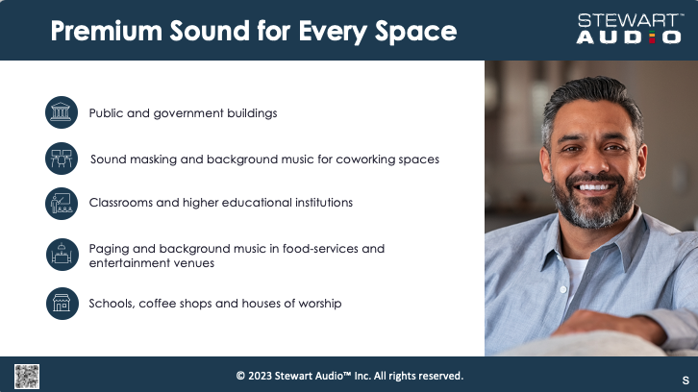

Segue to Doug

Doug – Sales Portal

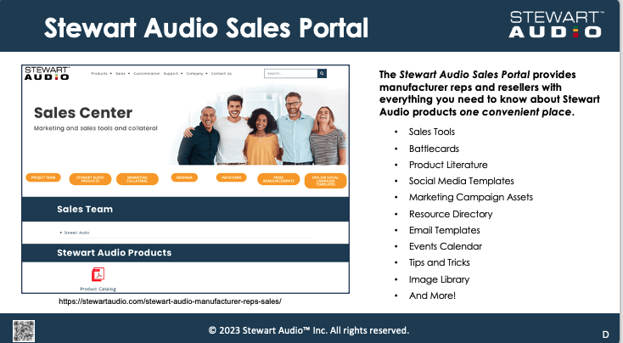

Segue to Stephen

Stephen – Q & A


- At this time, we’d like to take any of your questions. If you have questions, please enter them using the Q&A button at the bottom of your screen.

Stephen – Call to Action – Request for Manufacturer Reps to Invite to their Resellers to schedule a meeting with Stewart Audio at InfoComm2023

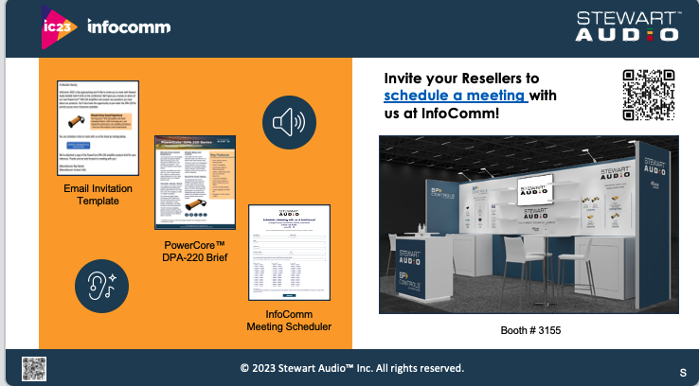

- As most of you know, we’re going to be exhibiting at the InfoComm show in Orlando from June 14 – 16 and we’d like to invite you and your resellers (integrators, installers, etc…) to meet with us in person at our booth.
- To make it easy to invite and schedule a time for you and your resellers to meet with us, we’ll be sending you an email template after this webinar that you can use to send to your resellers. There’s a button in the email that they can click to let us know their availability and we’ll take care of everything else to get them scheduled. It’s super-easy!
- Or if you happen to know your and your resellers availability right now, you can schedule a time to meet with us by scanning the QR code on your screen with your phone. It will take you right to the landing page where you can schedule a meeting. a

General Housekeeping
- BTW, we’ll be sending you a product brief for the PowerCore™ DPA-220 Series as well as a copy of these slides after the webinar, so please look for these in your email.

Stephen – Thank you and Close



- On behalf of everyone at Stewart, I’d like to thank you all for coming to our webinar. We hope that you found today’s presentation useful and we look forward to working with you and selling PowerCore™ DPA-220 amps! Thank you!

🟥 Turn off Recording

