




Ensure Resiliency Against
Cyber Threats
Webinar and Live Demo
June 1, 2023 10AM – 11AM PDT

Keep your data flowing with continuous data protection
All attendees will receive a $25 gift card of your choice *

Enter Gift Code (when Registering): Gift25
Learn how to go beyond traditional backup and recovery to get continuous data protection for your organization. Secure your backup data in an immutable format, whether on-site, off-site or in the cloud.

CloudPro | Assured | Rubrik Webinar
Ensure Resiliency Against Cyber Threats
June 1, 2023 10AM – 11AM PDT
Join this webinar to learn how:
- Secure your backup data in an immutable format
- Detect anomalies, large data changes or suspicious behavior in your backup environment
- Recover from ransomware attacks, on-prem or in the cloud, with near-zero RPOs & RTOs
- Recover all your critical IT systems in minutes and hours, not days or weeks
- Replicate critical data to a secure, off-site location to keep operations running
Receive a free pair of Nike shoes designed by you when you sign up for a free Assured Data Protection trial. Available in North America only.** | 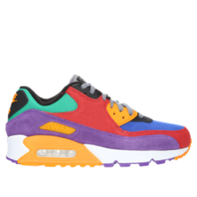
Presented by
Eric Haya
CloudPro, VP of Solutions
Greg Hooper
Rubrik, MSP Solutions Architect
Brian Dutton
Assured, Director, US Sales and Client Services

* Limit 1 gift card per company.

** By invitation only. Attendees must be pre-qualified to participate in the workshop and receive a pair of custom designed Nike shoes. Limit one pair of shoes (up to $200) per company. This promotion is not sponsored, promoted, endorsed by, or associated with NIKE, Inc. Only available in the U.S.

Copyright © CloudPro Corp. 2023. All rights reserved.
Copyright 2023 © Assured Data Protection Limited. Company no. 10161043
Copyright © 2023 Rubrik – Zero Trust Data Security™. All rights reserved.

