Subject: [Invitation] Meet with Stewart Audio at InfoComm 2023

Hi [Reseller Name],

InfoComm 2023 is fast approaching and I’d like to invite you to meet with Stewart Audio (Exhibit Hall # 3155) at the conference! We’ll give you a hands-on demo of our new PowerCore™ DPA-220 amplifiers and answer any questions you have about our products. You’ll also have the opportunity to pre-order the DPA-220 for priority access once it becomes available.

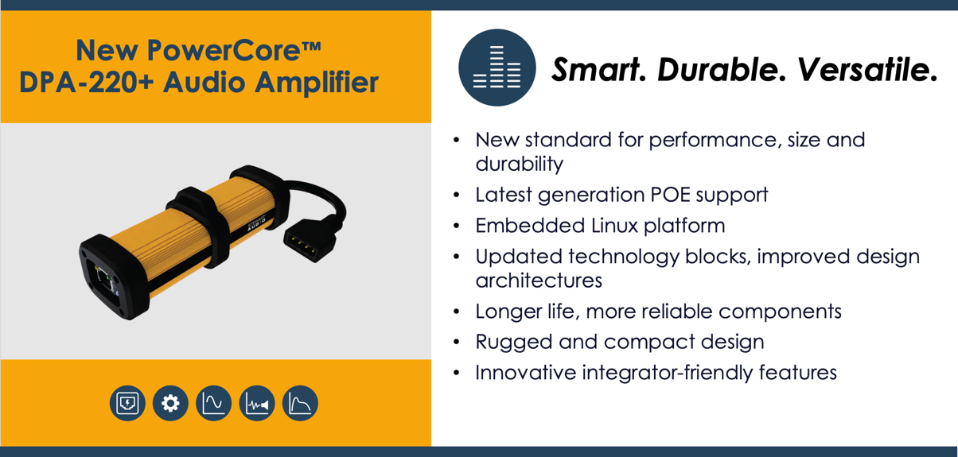

You can schedule a time to meet with us at the show by clicking below.



We’ve attached a copy of the PowerCore DPA-220 Series product brief for your reference. Thanks and we look forward to meeting with you!

[Manufacturer Rep Name]
[Manufacturer Contact Info]

