Subject: NetApp Cloud Migration Workshop for [Company Name]

Hi [Name],

I wanted to invite you and any other members of your organization who might be interested in participating in our new one-hour NetApp Cloud Insights Workshop. This custom workshop, which is co-presented with our solution provider CloudPro, is designed to address the top cloud migration issues [Company Name] is facing in the cloud.

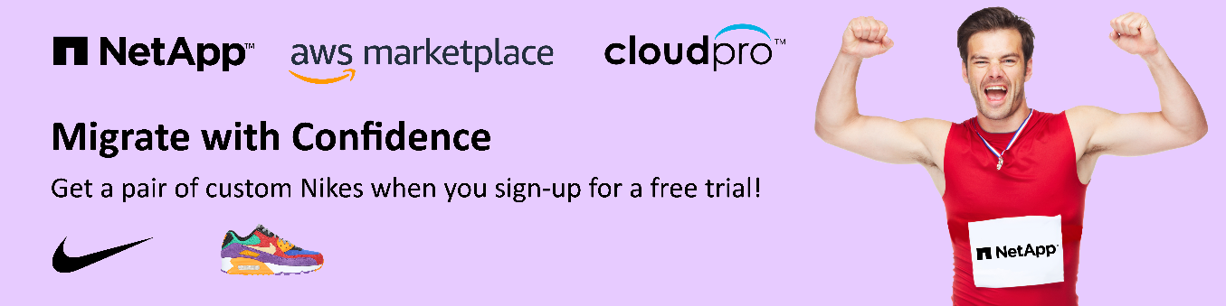

In our virtual workshop you’ll learn how Cloud Insights can help you before, during, and after your cloud migration. You can easily manage all your hybrid-cloud assets and get a side-by-side utilization and cost comparison, allowing you to avoid costly initial over-provisioning of cloud resources. Cloud Insights is the gold standard when it comes to optimizing all your resources and applications across your entire technology stack.

In addition, you’ll also get to design your own pair of Nike shoes when you sign-up for a free trial! Click the button below to sign up for the Cloud Insights workshop.
Sign up for our workshop!

Please contact me if you have any questions or if you need help signing up. Thanks and I look forward to showing you how Cloud Insights by NetApp can help you immediately start lowering your cloud spend and provide valuable insight for your cloud migration.

All the best, [Name]

