Hi [Name],

I hope you’re doing well! I wanted to extend a special invitation to you to attend our NetApp Cloud Insights Workshop we’re hosting with CloudPro on Wednesday, 7/27 at 10am PST.

In our one-hour virtual workshop you’ll learn how Cloud Insights by NetApp can help you immediately reduce costs, optimize your cloud and protect against ransomware attacks. Cloud Insights is the gold standard when it comes to optimizing all your resources and applications across your entire technology stack.



In addition, you’ll also get to pick out and customize your own pair of Nike shoes when you come to our workshop and sign-up for a free trial!

Be sure to register today, as space is limited!

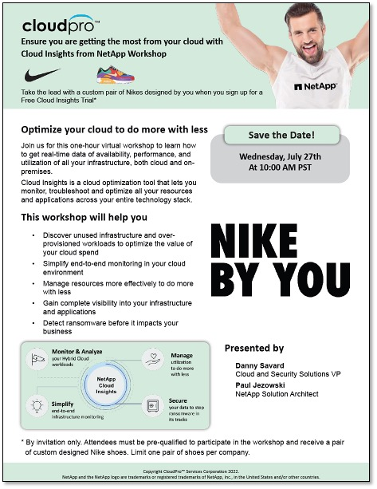

Please contact me if you have any questions or if you need help registering. Thanks and I look forward to hopefully seeing you at the event!

All the best, [Name]

