LinkSource Cloud Insights Workshop Script
Ver 5.0

Workshop Introduction - Frank

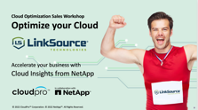

- Hello Everyone!
- I’m Frank Mastro.
- I’d like to welcome you to our Cloud Insights Optimization Workshop. We have a very exciting and informative session planned for you today!
- I’d also like to mention that we will be recording this workshop for those of you who would like to share today’s workshop with colleagues.
- During the next hour you’ll learn how to optimize your cloud utilization and performance while dramatically lowering cloud spend with AWS, Azure and Google Cloud.
- This program has been divided into three parts.
  - The first part was when we met with most of you to understand your current business and technical challenges. We’ve compiled this feedback and will share what we’ve learned with you during our workshop exercise.
  - The second part is today’s event where we’ll hear about how companies are growing their businesses by migrating and managing their workloads in the cloud. We’ll also learn how NetApp Cloud Insights is helping them manage and optimize their cloud workloads as well as the steps you can take to get the most out your cloud investment.
  - And lastly, the third part is to set up your free trial, place your order for your pair of custom Nikes, answer any questions you have about Cloud Insights.

Introduction to CloudPro and NetApp - Frank

- I’d also like to introduce CloudPro and NetApp who will be presenting with us today.
- Today we have with us
  - Bryan Vadell, NetApp Cloud Insights Solution Architect
  - Doug Kryzan, CEO of CloudPro, a cloud professional services and engineering firm
- They will demonstrate how you can more cost-effectively manage your cloud and answer any questions you have during today’s session.

Workshop Agenda- Frank

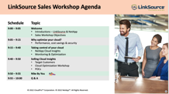
- Here is our agenda:
  - We’ll first hear from Doug who will talk about why cloud monitoring and optimization is important
  - We’ll also hear from our CEO Curt Lewis, who was able to save 70% of their monthly cloud spend through a CloudPro application optimization assessment. Today, using Cloud Insights, this process has been automated through the service’s advanced cloud monitoring and reporting capabilities.
  - Then Bryon will tell us how NetApp’s Cloud Insights makes all this possible. He’ll show how this service is simple and cost-effective to deploy and how it can immediately help you save money.
  - And lastly, we’ll show you how you will be able to order your own custom Nikes.



- If you have any questions during our workshop, please enter them in the Zoom chat window and one of our cloud experts will be happy to answer them for you.
- Next let me introduce you to Doug who will talk about how cloud monitoring and optimization is now the new business imperative in the industry.
- Doug, over to you!

CloudPro Overview – Your Business Accelerated - Doug

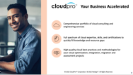
- Thanks Frank!
- We’re a born in the cloud NetApp partner and solution provider.
- We offer professional services such as cloud optimization, monitoring, advisory, and migration services to our clients.
- We work with both large companies such as DoorDash and Tesla as well as smaller mid-size companies.
- We medium and large organizations get the most out their cloud investments through advanced technologies like NetApp Cloud Insights.

NetApp Overview Industry-leading cloud services – Doug

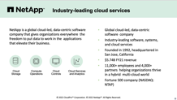
- NetApp as many of you probably already know is at its core a software company. You may remember NetApp from their early days for their filers, also know as Fabric Attached Storage.

- But, NetApp has evolved quite a bit over the past 30 years and is now focused primarily cloud data services and storage solutions.

- Specifically, NetApp helps businesses manage their applications and data across the cloud and their own on-prem environments.

- Today, we’ll be talking about NetApp Cloud Insights, their cloud monitoring and optimization service for mid-size and enterprise companies.

Understanding your Cloud – Doug

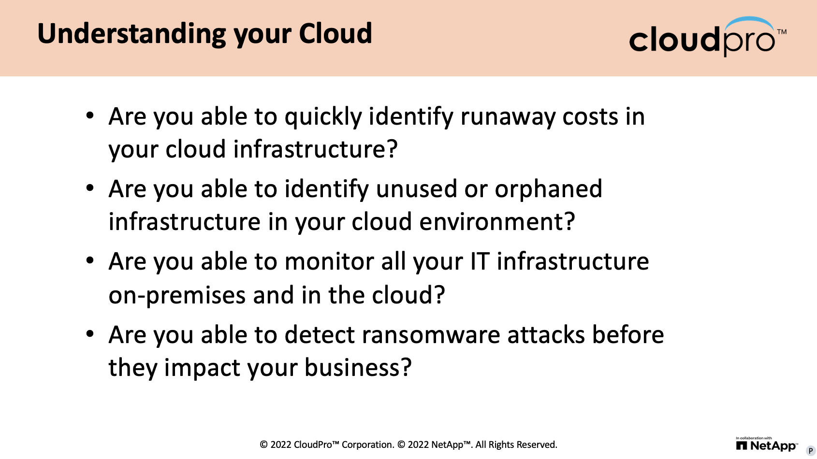

- Doug to lead conversation with Golden 1.

Getting the most out of your Cloud – Doug

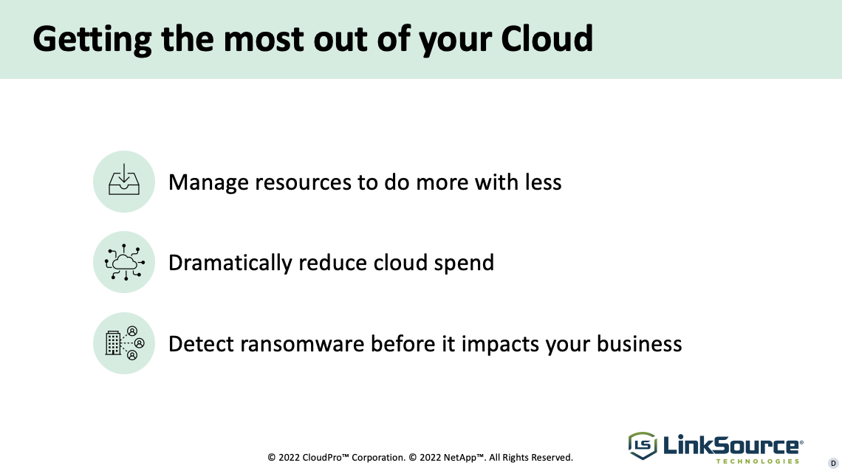
- The key theme of our workshop is how do you get the most out our cloud investment.
- We will explain why effective cloud monitoring and optimization is a business imperative, especially for companies like Golden 1 who need to ensure that their Cloud infrastructure is supporting their goals of providing a high-quality customer experience and reliable, always available online banking and financial and services.
- Cloud Insights boils down to 3 things.
  - Manage resources more effectively to do more with less
  - Detect ransomware before it impacts your business
  - Dramatically lower cloud spend on day one
- The example I like to use is that if companies aren’t monitoring, managing or securing their cloud effectively, it’s like flying a plane without radar. It’s only a matter of time before you either crash into mountain or get hi-jacked.
  - Security - If your customer is in the cloud and they’re not proactively protecting their data through early detection and automated responses to threats, then it’s only a matter of time before they’re hacked and their data is held for ransom.
    - And here’s the reason, why NetApp, and why NetApp Insights. No other company out there understands data and protecting your data better then NetApp.
  - Resource utilization – There’s a very high likelihood that you’ve overprovisioned your cloud storage and compute. About a year and half ago, our company worked with Curt and Jason on Direct RFP and as part our assessment we identified how we could reduce their cloud spend by 70%. Their dev/ops environment was overprovisioned. And fortunately this was discovered so they could finally stop paying for capacity they weren’t using.
  - Free Trial - It’s fast it’s easy and it’s free. We hold your customer though the process and it takes as little as an hour to do.

Cloud Insights Benefits Across the Organization– Doug

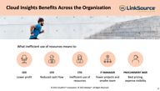
- Cloud Insights benefits all types people in the organization from the CEO to the SRE to Procurement.
- This is important because while you may be working with a CXO in one of your account you might be working with a an IT Director or Procurement Manager in another.
- Cloud Insights offers tangible benefits for each of them, from cost savings, to ransomware protection to greater visibility of cloud spend.
- I’ll talk more about this later. But next I’d like to introduce you to Paul who will talk more about the specific capabilities and benefits of Cloud Insights.
- Bryan over to you!

LinkSource and DirectRFP – Curt

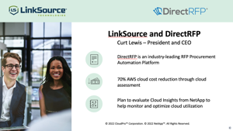
- Curt or Frank to present.

Nike – Cloud as a Strategic Priority – Doug

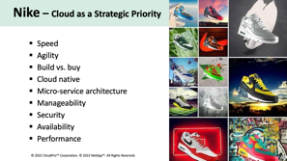
- Nike has been aggressively moving to the cloud to enable speed, scale, and a high-quality customer user across all their lines of business.
- Over the last five years, they’ve completely re-imagined their entire technology stack using monitoring, optimization and security as core principles for its cloud infrastructure.
- Nike realizes that cloud monitoring and optimization is a strategic priority — not an afterthought.

Nike is building a massive digital advantage – Doug

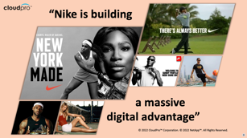
- Nike recognized that they needed to accelerate its digital transformation because it helped strengthen their connection with customers through individually-tailored content.
- Nike relies heavily on the cloud to provide personalized apps with up-to-date content and a responsive online shopping experience for its customers.
- The ability to monitor, optimize and secure is helping them build a massive digital business.

Cloud Insights Solution Architect – Bryan
Slides 14 - 30
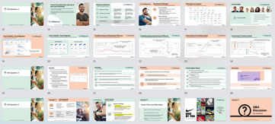

Speaker notes for Bryan’s section:

Good morning, everybody or good afternoon, wherever you're located. I'm Bryan Vadell. I'm a cloud solutions architect located in the San Francisco Bay area, and I am primarily responsible for working with the Cloud Insights product. This morning I'm going to give you a brief introduction to Cloud Insights. There's a lot to it and usually it takes about an hour to run through a lot of this stuff. 45 minutes to give you an in-depth preview of it and answer your questions directly, but we're going to take a high level look at it today. We're going to look at several use cases and how Cloud Insights can help in those situations. Next slide please.

So what can you expect by deploying Cloud Insights in your environment? Here's a few outcomes that you can see on the screen here, but more importantly is who is impacted by these. So, for example, analyzing relationships between shared resources and how they impact each other, who might benefit from that. Well, certainly an IT administrator, because it helps reduce the mean time to resolution but not only that, work your way up the organizational infrastructure. If you have an SRE, a site reliability engineer, where their main task is to ensure that applications are up and running, or service is up and running, they need to know when they have an issue or the ability to proactively avoid service degradation or outages is important to them and Cloud Insights can help with that optimizing and identifying waste. We heard Curt earlier talk about identifying resources that are being wasted with Cloud Insights. You can visually see your resources that are underutilized or not being utilized. On the flip side, you can also see resources that are overutilized and could be candidates for retiring and we'll take a look at that as well. I do have some screenshots of some of that from Cloud Insights but basically what I'm trying to say here is that folks up and down the organizational stack in the IT department can benefit from Cloud Insights from the C-level to understanding what your resource consumption is and what it costs down to the administrator who's really trying to fix things and handle cases and things like what is causing problems and it also translates over to the business as well how do you understand what the true cost of let's say an application is. Can you track your application infrastructure cost accurately with Cloud Insights? You can do that, and I'll tell you how when we get to that slide. So, what makes Cloud Insights a little bit different than other tools? If you're in the cloud you're using cloud tools like a WS Cloud watch or something like that. The issue with some of those tools is that they're really just monitoring what's in that environment, not necessarily cross cloud. What happens if you have a presence in AWS and Azure and Google. How can you look at those side-by-side and make a comparison with normalized data? This is just an example, what's called a TB in AWS might be a little bit different than what's called a terabyte in Azure or in Google. There might be slightly different definitions or what those numbers mean. Cloud Insights normalizes that and gives you an equal playing field to evaluate all of your environments. And the other thing I want to emphasize here, and we'll touch upon this a little bit is Cloud Insights has a functionality called Cloud Secure which provides you the ability to detect ransomware and abnormal user behavior or malicious user behavior and there's a lot of that going around today. Next slide

Frank: Hey folks, I just want to throw out that we have a chat window that's open. Feel free to ask some questions.

Excellent Frank, thanks for the reminder. So, what are some of the challenges that the companies I deal with see today? I'm sure some of these exist in your environment…poor application performance, how do I prevent outages. If you could proactively address these potential issues would they be of benefit to you? What does that do to your service? It helps you; it enables you to deliver on your SLA’s and SLO’s and your over provisioning cloud resources. If you're migrating to the Cloud now do you know what that target platform needs to look like? Here's an example. If you look at AWS and storage for example, they have various categories of storage. There's IO one there's IO2 there is GP1 GP2. There are various kinds of storage categories in AWS and the way you size that is you look at they tend to say IO density. How many IOPS per terabyte is your workload? How do you know that Cloud Insights can do that for you? I had a customer that has migrated to the Cloud, and I showed them a dashboard that I had created for them, and they were impressed because it makes their life a lot easier. They can see what this particular workload is requiring. As an example, you know 3000 IOPS per terabyte then they can easily go over to AWS and say oh well I 01 doesn't meet that need but I 02 does. That's likely the platform that we’ll need. So, these are some of the things that you can do with Cloud Insights. I'll throw a question out to the folks in the audience. Do you see some of these challenges today in your environment? I'm almost sure the answer is yes, and nobody wants to say I have poor application performance or I’m over-provisioned.

Curt: I do have a question that might be a little outside of this. One is, are there notifications that could be provided or sent to people like myself so I at least have some thresholds around the utilization and does Cloud Insights also have the ability through the tools spinning up servers and on top of that would I also be able to get some notification when I know people are spinning up other services that actually turns into additional costs to me?

Bryan: A two-part question there. The answer to the first one Curt is yes, we'll actually see a slide about alerting that really ties directly into what I had mentioned earlier, proactively addressing potential issues that can cause outages or service degradation. And your second one. Help me understand a little bit better.

Curt: Can Cloud Insights detect as my developers and IT folks are spinning up more and more servers to accommodate the environment can I get notifications that actually come through the tool or no is that just done directly through the AWS site?

Bryan: I’m thinking about how we collect that data. Cloud Insights collects performance in an inventory information around things like VMs whether they be in AWS or on-prem. And we collect those things like IOPS capacity and whatever but what we can do is count. So, for instance, today you have a 100 AWS VMs in your environment. We don't necessarily have an alert that will say hey you've spun up another 20 VM's right, but what you can do is on a daily basis have a dashboard and we have dashboards that have been created at least at the admin level which is a daily check-in dashboard. And some of them pertain to storage, some of them pertain to compute, but in your instance, you could have a very simple dashboard that displays today I've got 100 VMs spun up. Tomorrow if I check the dashboard, I might see 300. That's cause for investigation, but we really don't have an alert that'll say I’ve spun up…
Curt: Actually, the dashboard would help tremendously. So yeah, if I can get that from the dashboard that would work great for me.

Bryan: Yeah, but then you could see the trend. You can see over time how many VMS. On Monday I had 100. On Tuesday I had 300. On Wednesday it dropped down to 150. I could do a trend over 30 days, over up to 13 months and things like that. So that's trend analysis. Next slide please and again folks if you do have more questions as we're going through this just put them in the chat window and we'll bring them up right away for you. Great thank you. So, a little bit about Cloud Insights. It is a SAS based service and I'll allude to that in a second. It's a SAS based service that provides monitoring for your heterogeneous hybrid Cloud environment. What does that mean? You can see some of the platforms that we natively support here on the screen. We've got various endpoints and endpoint is each of the squares here. There are platforms such as NetApp, VMware. There are OS such as Linux and Windows but there are services as well like Kubernetes or Couchbase or Docker as well. Some of those are hidden behind each screen capture there but notice there's A.WS this Azure and behind one of those screens is Google as well. Next slide please. Oh, I forgot to mention why is SAS important to you. There is no maintenance needed. There's very, very, very little infrastructure that needs to be deployed on-prem. There's no maintenance, there's no patches. They're automatically pushed on a regular basis to your Cloud Insights instance. There's nothing you have to do. Why is that important? Think about what has occurred over the last few months. How much of an effort is it to patch your applications around that? No need to do that with Cloud Insights. It is done by NetApp engineers on the background. It's automatically pushed out; you don't see anything so that's a real benefit to Cloud Insights.

I see a question in the chat. How does Cloud Insights prevent and detect attacks from ransomware? Great question. We will address that a little bit later. I do have a specific slide around that. So, at this point we'll take a look at a couple of use cases and how Cloud Insights can address those use cases. So, for instance, cloud visibility. If you're already in the cloud or you're migrating in the cloud what do you provision, how much do you provision, are you provisioning the right resources? Troubleshooting and operational efficiency. How long does it take you to resolve a problem? Where do you begin? How many tools do you use? How many departments do you have to tie together your server department? I mean do you have to interact with your server department and your storage department? Forecasting and trend analysis. Are you making infrastructure purchases with accurate information? How do you do that? Are you able to trend consumption of your resources and accurately forecast what you need for resources in the future? And lastly, we'll take a look at security. This is the Cloud secure function within Cloud Insights. Again, minimizing data loss due to ransomware or tracking and blocking abnormal user behavior. So, let's take a look at the next slide.

These are some of the screenshots that help address these use cases and again we collect so much data this is just scratching the surface. This is a representation of some of the dashboards and reports. There is so much more that can be displayed or shown to you and likely address your specific needs. In this case, this particular report is showing me a couple of things. There are two things to think about here. One, I'm comparing costs of my on-prem to AWS, Azure and Google compute. Mind you these are list prices but what I'm able to do is model my compute consumption and my compute costs so that's one benefit of using this report. The next one is if you look at the scatter graph in the lower left there, that is a plot of all of the VMs in my environment. Not mine, this is an actual customer. When I look at this, it's a plot of memory versus CPU utilization. What I see here is there's a cluster towards the lower left of this scatter graph and it's telling me that either the VMs in my environment are underutilized because you can see 10% and 20% of both memory and CPU utilization. They're either not really used, if they're underutilized or they're over provisioned. Now Curt I don't know in your example where you saw your cost savings. Was it over-provisioning or was it just lack of use?

Curt: It was definitely over-provisioning.

Bryan: Yeah, and why is this important? Especially if you're migrating, I know customers that are just doing lift and shift or they're refactoring. However do you understand what that workload requires for its performance? Do you understand what that workload performance requirements are beforehand so you just don't spin up the fastest most expensive AWS VM and pay for it? So, this helps you avoid initial costly over-provisioning, and this is a report from Cloud Insights. Next slide please.

Guy: Bryan, this is just a quick question. It may help the audience. So, you just talked briefly about migration. Can you explain a little bit more about how Cloud Insights can help their customers with the cloud migration strategy?

Bryan: Absolutely. I alluded to that. I've worked with customers that have said first off, a cloud migration is not an easy thing. I had a customer that I started talking to about a cloud migration probably three years ago. And every once in a while when I check-in it's like well how's the migration? It's like yeah, we haven't started it. Why not? We're having a difficult time understanding our workloads. So, one of the things that they could benefit from is exactly what I had mentioned. Analyze the workloads ahead of time, understand the performance and capacity requirements and provision appropriately. And it ties back into…Curt, I don't know if this was during your migration process, or you were already established in the cloud.

Curt: Already established.

Bryan: Ok, you were already established in the cloud so Cloud Insights can help you with that but during the course of your migration you can easily see over time and it's not just an instant point in time like today here's the requirement. You can look at your average requirement over 30 days, 90 days, 12 months, etc and determine that hey this application or these VMs require this type of resource. That's how it would help. So, moving to the cloud is more than just picking up lifting and shifting its planning. Let's go to the next slide please.

To your point Curt, here's an example of being able to alert with the alerting function within Cloud Insights you can proactively avoid outages or service degradations. In this particular example here, I'm looking at a storage node and it's showing me that the one that the arrow is pointing at is above a threshold that upset, which is critical. This happens to be a NetApp storage array which is an AJ pare and if one node fails over the other node will pick up the workload. But I caution this customer and I said look this particular node is constantly over 65% or 60% or whatever the threshold is. You run the chance of service degradation if you have a node failure and the single node remaining has to pick up the workload. So, it can help you avoid these potential issues and outages and again this is important to not only admins but people like site reliability engineers or application owners or application architects understanding your workloads. Next slide please.

One of the key features of Cloud Insights is the ability to correlate resources that are related to each other. So, for instance, I might have a volume that is telling me that I've got a lot of latency in it, and I go to investigate it. What is happening, how do I know what is causing that latency? On the right side of the screen here, I call that the correlation area. This is correlating the workload of, this particular instance, this is this is found that the workload of 1 VM is impacting the other VM here. So, the workload I'm examining is the one with the blue square. The workload that's greedy is the orange square there. And you can see the peaks of the graph here. The orange IOPs has a direct relationship to the latency in the top graph of the impacted VM. This type of capability greatly reduces your mean time to resolution. Next slide please.

Forecasting and trending analysis. Here's an example of how Cloud Insights can help you more accurately predict your resource requirements for the future. In this example we're looking at a storage array and it's showing me that over the next 12 months I can expect, based on current usage, that this storage array will be declining in consumption. That's what the bottom dotted line is there. The top dotted line is actually what I have for capacity in that storage array now. I worked with customers where that angle is completely opposite and the lower bar the lower line intersects the upper bar within like six months or 12 months. But then again, they're growing at a rate of like 10, 12 or 20 terabytes a month. So, it helps them understand where they could potentially run into a capacity problem and also plan their purchases more accurately. Next slide please.

This is a report that's gaining interest among my customers. As an executive you don't necessarily need to delve into the nitty gritty the bits and the bytes here. This report at a glance is going to show you very simple red, yellow or green. Do I have an issue here or not? In this example on the left side is storage capacity you can see capacity risk. On the right-side performance risk associated with my storage. I can clearly see here that I should respond, or I should reach out to my IT organization and say hey guys we could be having an issue on some of these storage controllers. You might want to have a look because I'm seeing red and yellow. It's a very easy way to understand what's going on in in your environment. And the same type of report is available for compute. Next slide please.

OK security and Louis you mentioned how do we handle security. One of the features of Cloud Insights is Cloud secure. And as I mentioned earlier it detects ransomware and it can take action. It's based on user behavior so there's nothing like a whitelist or a blacklist or a file extension type. It strictly looks at the user behavior. And should it detect a ransomware instance it has the option to do a couple of things. One, it can take a snapshot. Two, it can isolate the user that that attack came out of. So, it'll prevent that user from continuing to write data. And it also will detect large deletes. So that’s another type of ransomware that we’re looking for. There’s ransomware encryption and there’s ransomware in the form of large deletes. So those are two types of ransomware that we monitor for. The other type of activity that we monitor with Cloud Secure is user activity. What happens if you have a malicious user? They might go in and delete a lot of stuff. They might copy a lot of stuff. There's AI and machine learning behind the scenes working here. It learns user work patterns over a period of couple weeks. If it finds something out of the ordinary, it will alert you and you can take action against that. And lastly, you can export this information to an Excel spreadsheet should you need to provide this information for audit purposes. I am getting a lot of requests to talk about security these days. Given the environment today, especially with what's going on, the threat of ransomware attacks has increased. I partner up with another peer of mine and we do not just a ransomware discussion but also a full security discussion on how best to protect your data as well as ransomware. Next slide please. We’re coming towards the end.

Sean: I just wanted to ask you know just to kind of give people a an idea of numbers wise, of the customers you're speaking with how many of those customers are you having with security discussion with? All of the above, 80%? I'm just curious what you're seeing out there.

Bryan: Whenever someone asks about monitoring, Cloud Insights, how can I optimize my environment and things like that it doesn't matter I always include at least 10 minutes of security. And more often than not, they realize you know I really didn't think about that. The real question I start out with is do you have a ransomware strategy? What is it? What do you have in place? I have to do an EBC or DVC as they call it now, a briefing center discussion next week. That's how popular it is. I generally get about a couple a month but that's just for my area. I'm not national, I just have the Bay Area so I'm typically doing maybe a couple a month.

Sean: One other thing, so I see Steve jumped on. Steve, I don't mean to put you on the spot but I'm curious at your end, since you have the country, what you're seeing as well.

Steve: There’s quite a bit across the country that I have been noticing from a pattern perspective. Obviously, security is going to be first and foremost. There is not enough security out there for our customers to safeguard their data. So, ransomware is coming in many, many different forms and how it actually attacks it actually morphs right so it's never a specific pattern so to pulse we don't look for specific artifacts we look for the behavioral patterns of a typical ransomware attack which is either two things that compromise a customer. The extraction stealing of that data or the locking of that data and holding it ransom so you could get it back. But the idea of that data being copied out is also something that we have to be concerned about. Not only did they lock it but if they copied it that means there's a copy of information that's going out there. So, it's a really important thing to understand what is going on in your environment. That's one pattern that I've seen for sure. The other one is really revolving around the ability for customers to truly understand where the risks are and your costs in managing the costs between the two. And that goes up and down the stack. So, your day-to-day operations how to manage the things that keep the lights on so to speak. But more importantly how does that roll up to executives to be able to make the proper decisions on what they should be doing with their environments. Whether it's migrating it, making it more efficient, future proofing it. There's new technologies that are coming out so when you do invest in something it should be something that can carry you forward into the future. Whether it be cloud, any cloud, a combination of cloud and on-prem. Or depending upon what you're doing it might be consolidating. I don't want to spend on so many data centers. I want to make it more of maybe two or three datacenters from 6. So, the cost, the risk aspect is really becoming more prominent out there in our conversations with the customers.

Bryan: As we come into the closing slides here. You know we've talked about some of these early on but what are what are some of the value of the benefits to you as a possible customer. I showed you how Cloud Insights can help you before, during and after a cloud migration. We talked about correlation and resource correlation and the ability to look at the full-service path and how it can help you reduce your mean time to resolution. Cloud Insights also provides rest API's that allow you to integrate with things like a CMDB so you can integrate Cloud Insights into your daily, weekly cost management processes. Next slide please.

And again optimization. The great example from Curt there. How he was able to optimize his AWS infrastructure. And lastly, we talked about Cloud Secure. Cloud Secure is going to help you limit your losses due to a ransomware attack or malicious user behavior. Next slide.

Some examples of current clients. You can see here that it spans various industries. I'm not going to go through them all and various use cases, but I will venture to say that in the last category there, globally known companies in consumer electronics, entertainment and pharmaceutical. I'd be willing to bet that every one of you in the audience has a product or has been entertained or has used pharmaceuticals by some of our customers today guaranteed. Next slide please.

Finally, feel free to work with your CloudPro team. We're more than happy to work with you on starting a trial or even conducting a POC. It's very easy. I've had customers up and running within an hour. It's that simple. Are there any other questions because this brings me to the end of my part.

Guy: So, you just mentioned it is pretty easy to get started. So, for any customers that might be interested in Cloud Insights, can you kind of maybe at a high level describe what's involved to get it implemented?

Bryan: Sure, what's required to implement Cloud Insights whether it be for a trial or whether it be permanently full time. Depending on the size of your environment, it really requires just a VM spun up in your data center where your systems are located, real small one, maybe 4 core maybe 8 or 16 megabytes of memory and 50 or 100 gigabytes of disk space. And it only has to be able to communicate out to the Internet. And again, via port 443 so it's a secure port. That's really all we require. I had a customer that had 70 petabytes of storage on-prem and they really only required 2 VMs. One in the East Coast data center and one in the West Coast data center and that was it so it's very lightweight.

Rob: It looks like there's a question from Frank Smith in the chat window.

Bryan: Let me see, security is a key for us. Frank, thank you. The information shared is great. Can you share anything about where the product is heading in terms of new security road map features? Is this a big area of investment for the product overall moving ahead? Great question Frank. I'm not necessarily at liberty to discuss road map features, but what I will say is that we will likely enhance the ransomware detection capabilities by looking for different types of ransomware patterns and different abnormal user behavior patterns. So, it makes Cloud Secure more robust. And that's what I can say right now.

Steve: I'm just make a point there is well you may want to consider this a feature as well. The integration with the data classification solutions that we have can definitely enhance the findings from a security perspective. For example, not only can we tell you what might be happening at the file level, when it happened, what happened, where it started who it started with and ultimately provide you the ability to control or isolate. Isolate, contain and extinguish it using you security platform tools but think about the actual data itself and understanding what the content of that file was that was compromised. That might be really important for you as well so not only were 1000 files compromised 250 of those files had confidential information in it. So that could be something that you might be interested in that data classification.
- Bryan turns the presentation back to Doug.
Survey Results– Doug

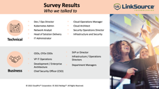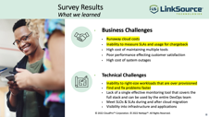

  - Doug reviews the survey feedback and then talks about their cloud optimization action plan and next steps.
  - Turns presentation back to Frank.

Ordering Custom Nikes and Free CI Trial - Frank

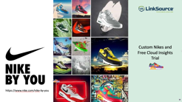
- Thank you Doug!
- Next we’d like to show how to order your custom Nikes.
- First, you’ll want to go to this URL to design your shoes. After you’ve created your custom design, let us know and we’ll get on a Zoom call with you to help you place your order and put it on our credit card. We ask that you keep your shoes cost to around $200.
- Also, at this time, the CloudPro and NetApp on hand to set up your free Cloud Insights Trial so you can see for yourselves how can immediately start saving money on your cloud services.


Q & A - Frank

- Since we a few more minutes, we can take one or two more questions if you have any?
- BTW, we will be sending a copy of these presentation slides to everyone on this call.

Thank you and Close - Frank



- On behalf of everyone at LinkSource, CloudPro and NetApp, I’d like to thank you all for coming to our workshop. We hope that you found today’s workshop helpful and we look forward to talking to you all very soon.

